Triple Threat
RULES: United States Practical Shooting Association, Latest Edition COURSE DESIGNER: Kirt McKenna
START POSITION: Handgun is loaded unpropped, lying flat on barrel with muzzle pointed down range. Wrists below belt.
PCC Start: Same as Handgun.
STAGE PROCEDURE  On start signal engage targets as they become visible from within the Shooting Area. | SCORING  SCORING: Comstock, 27 rounds, 135 points  TARGETS: 9 paper  SCORED HITS: 3 Best per paper  START-STOP: Audible - Last shot  PENALTIES: Per current USPSA Rule Book

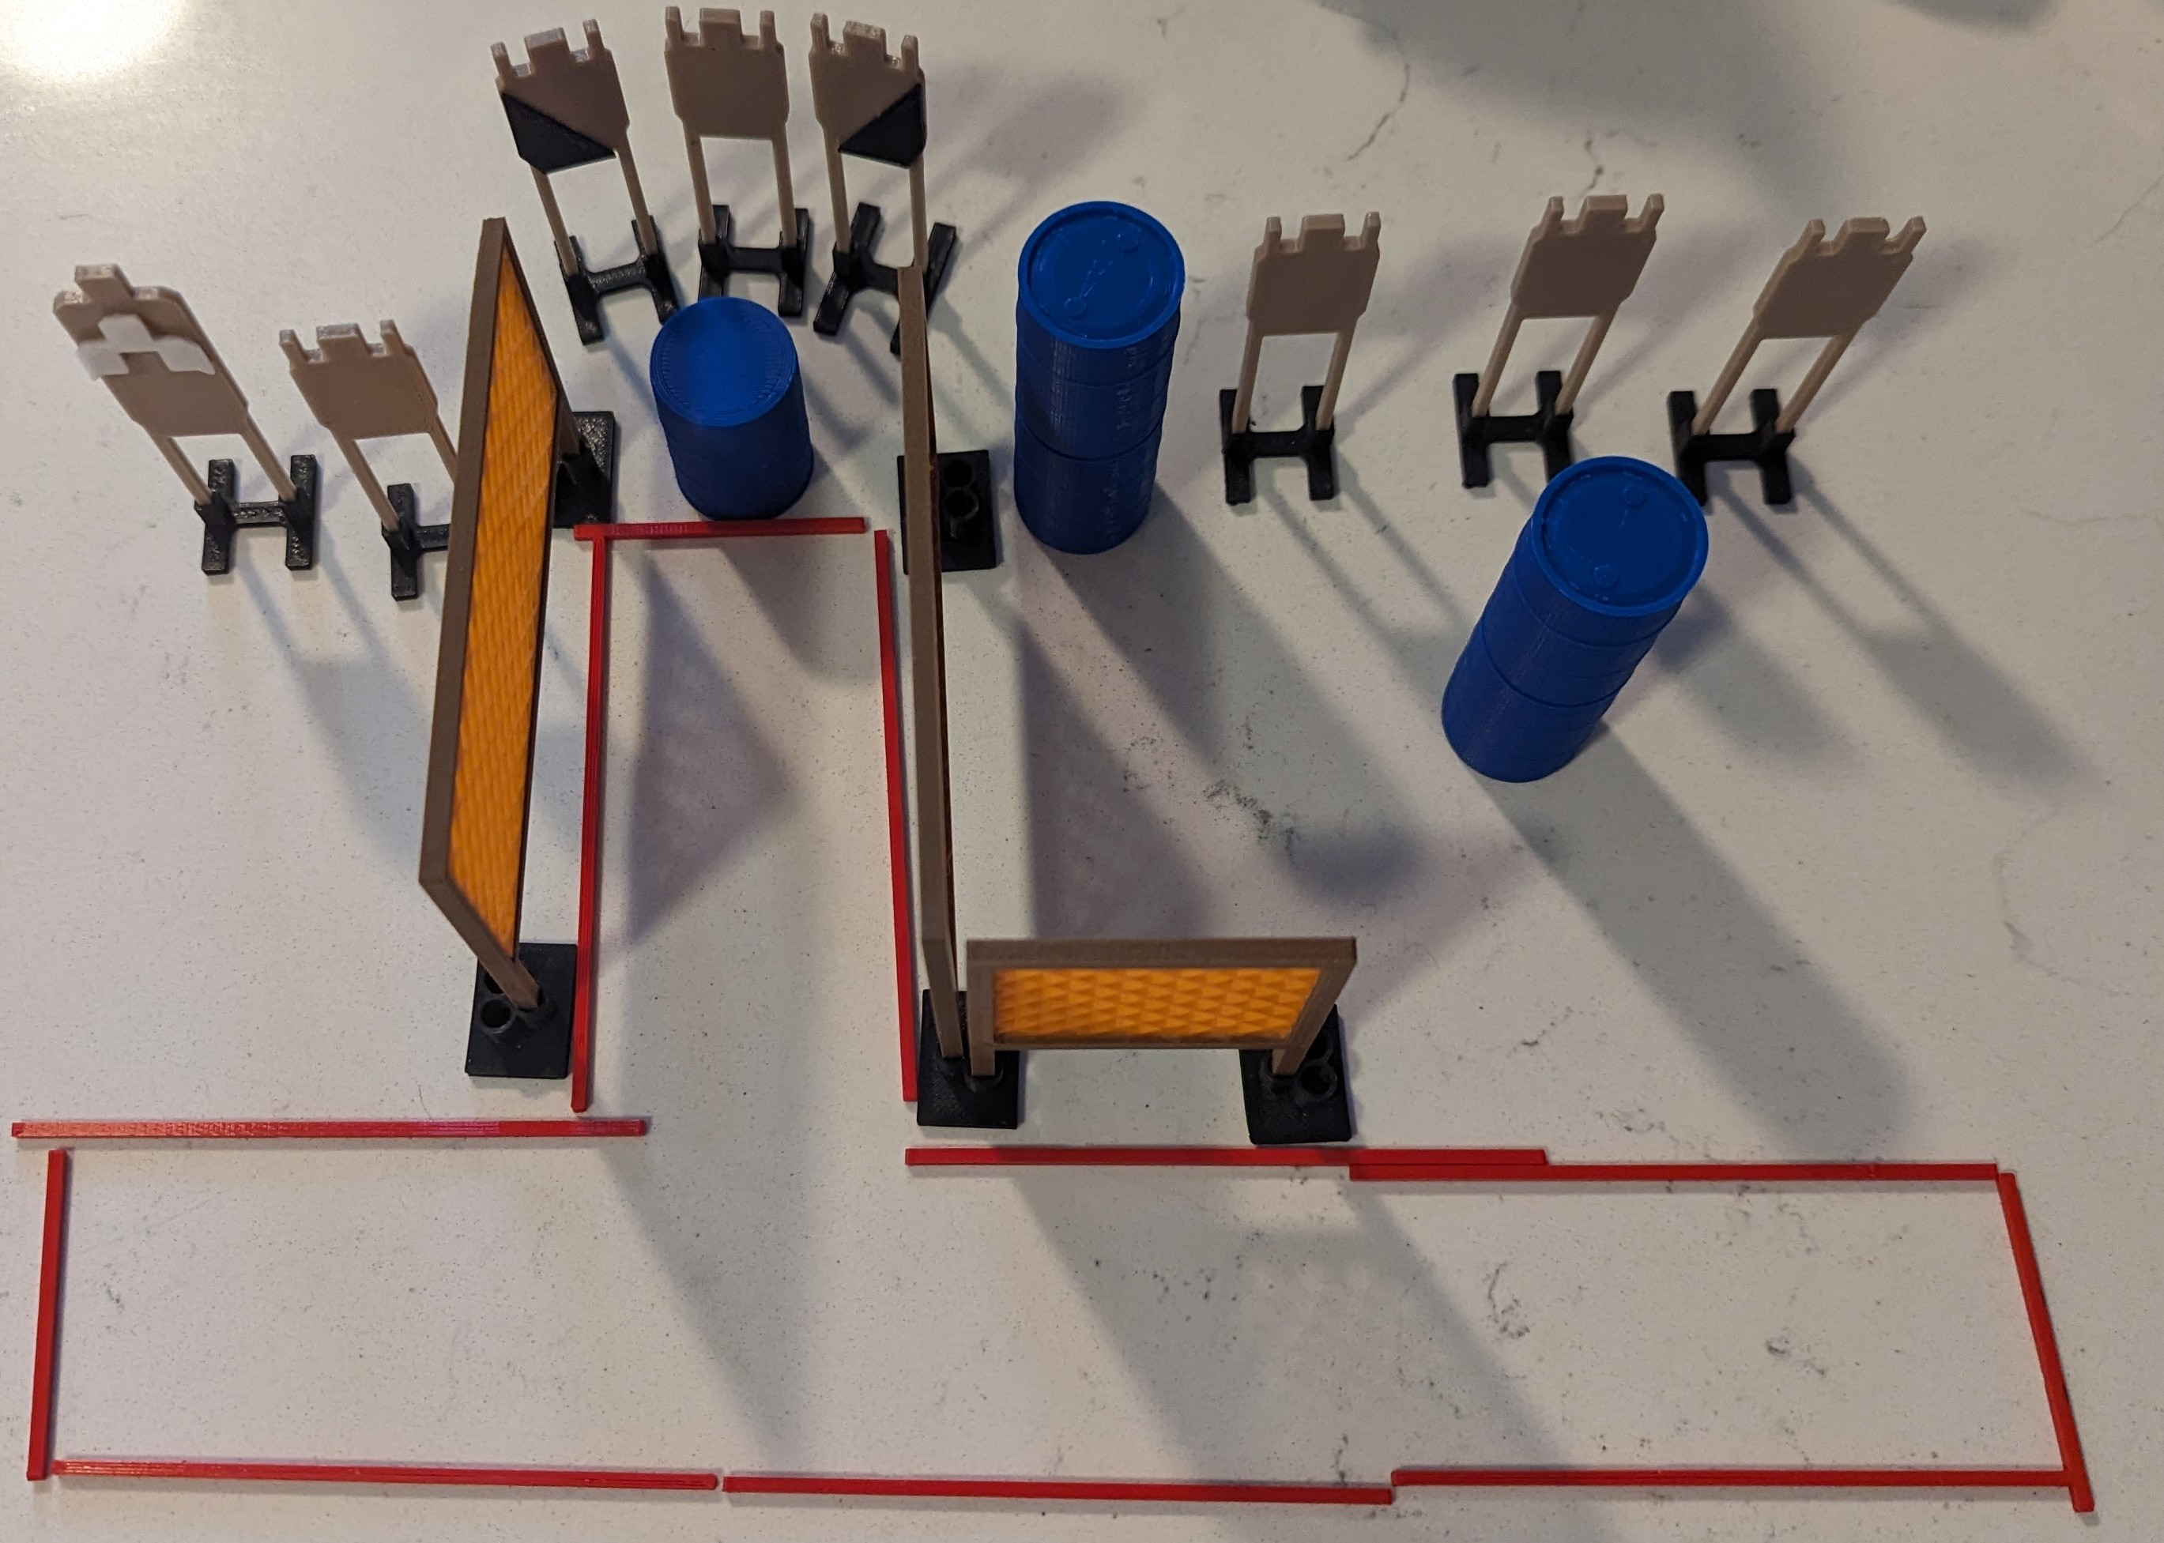

SETUP NOTES: |  | RO NOTES:

